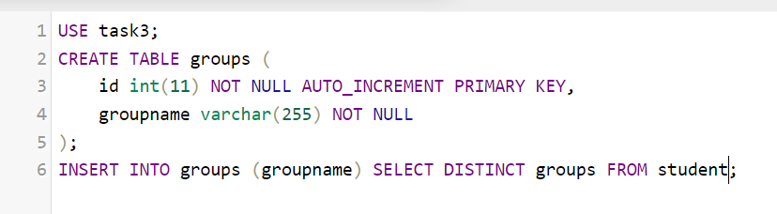
(id -> groupID)
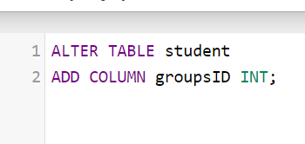
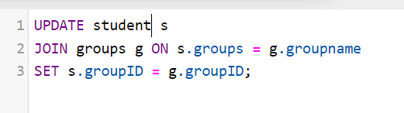
(also I tried to do “join” the other way)
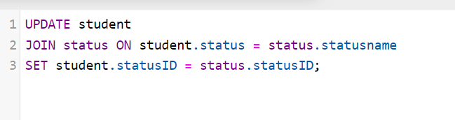


Did the same with “city” and “status”.
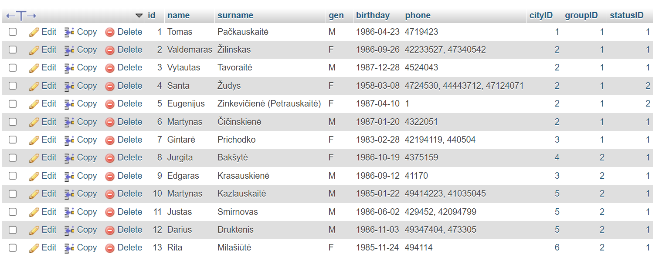
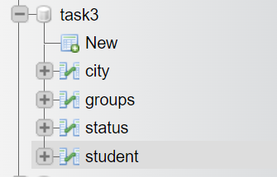

USE task3;
CREATE TABLE city (
cityID int(11) NOT NULL AUTO_INCREMENT PRIMARY KEY,
cityname varchar(255) NOT NULL
);
INSERT INTO city (cityname) SELECT DISTINCT city FROM `student`;

